1. cdAccess the dataset for this assignment,**city_inspections.json**, in the **/usr/local/datasets** directory in your Apporto environment. Using the **mongoimport** tool and documents found in the **city_inspections.json** file, load the database “city” into the “inspections” collection. Complete this task by typing the following commands in the **Linux terminal** to perform the import in the right directory:  
     
   Change into the Apporto directory with the data sets:

cd /usr/local/datasets/

Use the mongo import utility to load the data set:

mongoimport –-username=”${MONGO_USER}” \

–-password=”${MONGO_PASS}” –-port=${MONGO_PORT} \

--host=${MONGO_HOST} –-dbcity –-collection inspections \

--authenticationDatabase admin –-drop ./city_inspections.json

**Tip:** In any Linux systems, commands must be exact and use proper syntax and case sensitivity.

1. **Verify your load** by “using” the “city” database, and issuing the following queries in the *mongo shell*:
   1. db.inspections.find({"id" : "10021-2015-ENFO"})

* 1. db.inspections.find({"result":"Out of Business"},{"business_name":1}).limit(10)

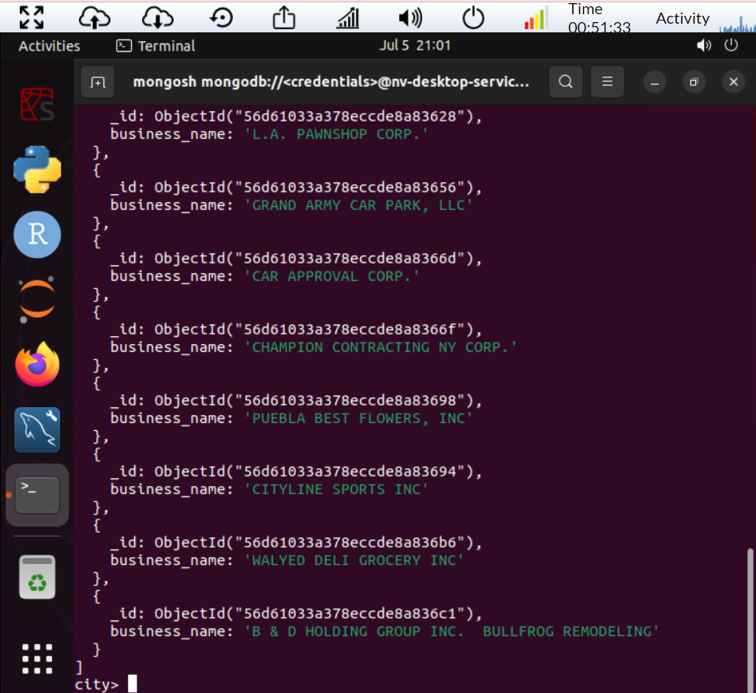

1. Using the appropriate commands in the mongo shell, **insert a document** to the database named “city” within the collection named “inspections.” Use the following key-value pairs as data for your document.

|  |  |
| --- | --- |
| **Key** | **Value** |
| id | "20032-2020-ACME" |
| certificate_number | 9998888 |
| business_name | "ACME Explosives" |
| date | Today's date |
| result | "Business Padlocked" |
| sector | "Explosive Retail Dealer-999" |
| address | number -> 1721 street -> Boom Road city -> BRONX zip -> 10463 |

Be sure to insert the address as a subdocument and use the JavaScript function **Date()** for “Today’s date.” Verify your database creation and insertion using the **findOne()** function in the mongo shell. Provide a **screenshot** as evidence.

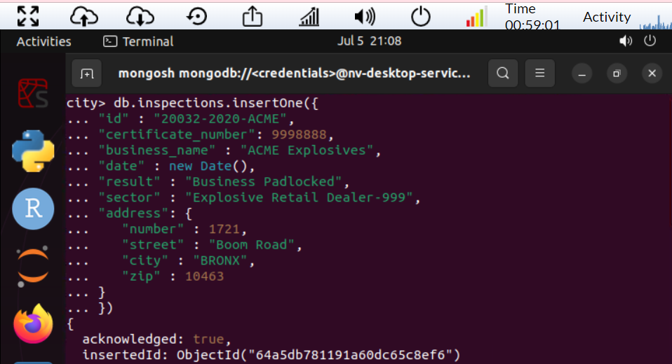

1. Answer the following questions using **MongoDB queries**.
   1. What is the distinct list of inspection “sector” in the current inspections collection? How many are in the list? Do not count by hand.

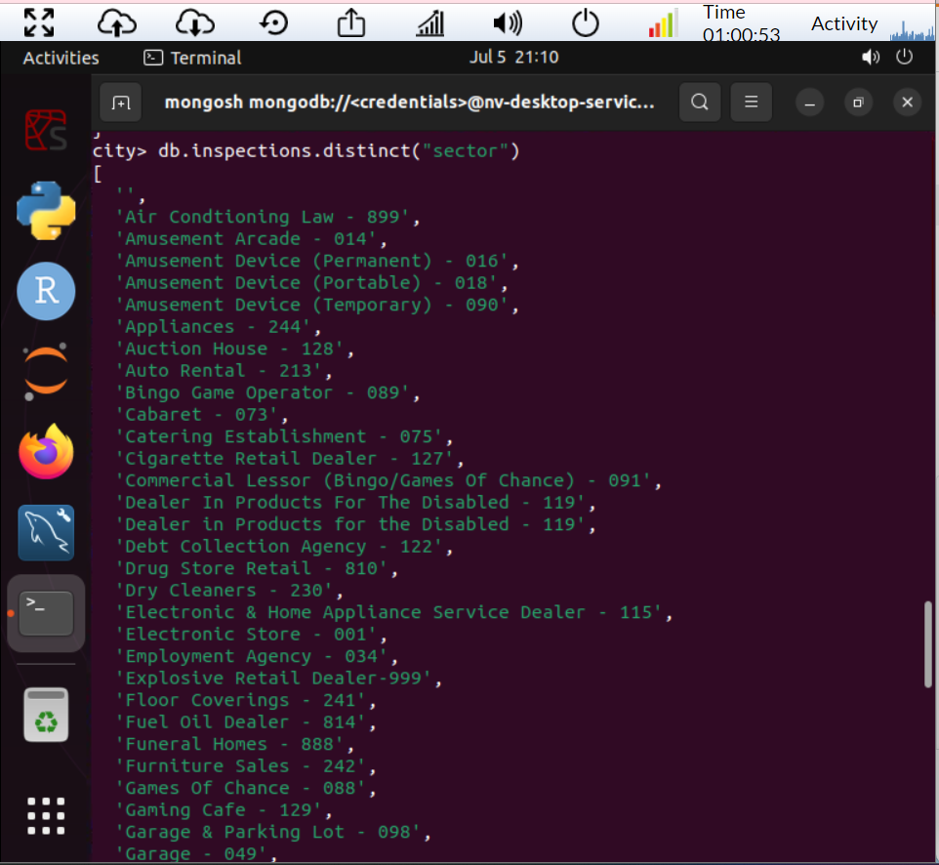

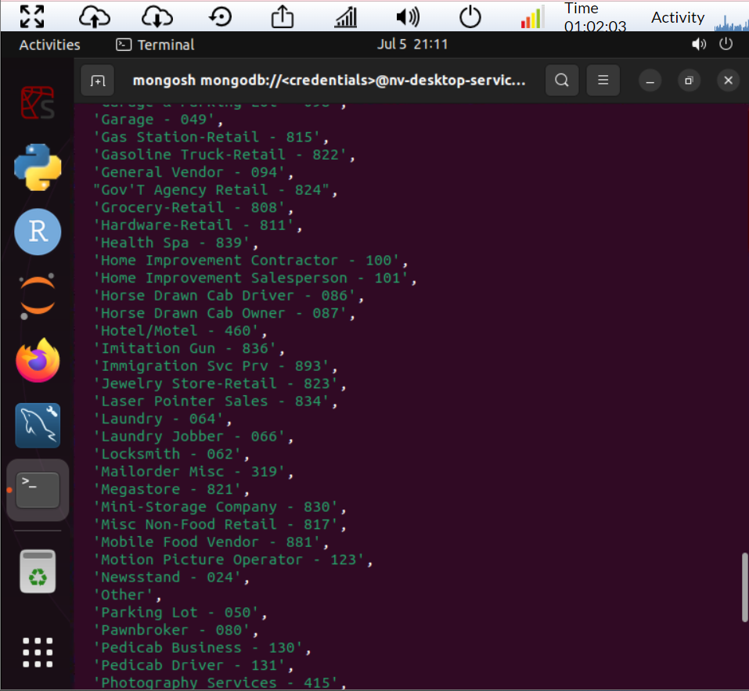

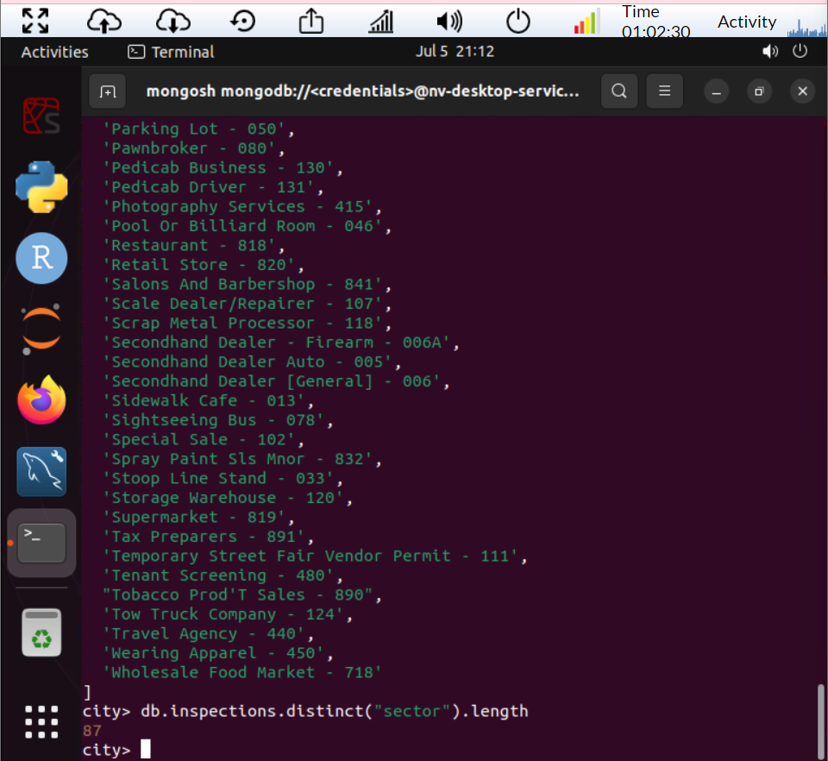

* 1. What is the difference in the date data type for the business named “AUSTIN 2012” versus your business document insertion of “Acme Explosives”?
     1. You can see that AUSTIN 12 business was created in 2016 from the database, while ACME explosives was in 2023.

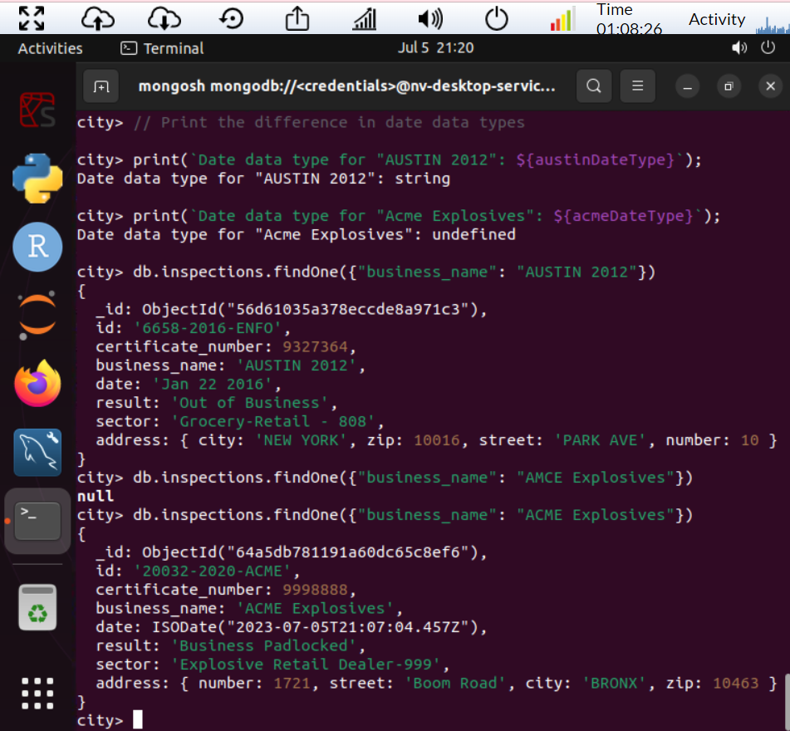db

* 1. How many businesses have a “Violation Issued”? (See **Value** column above.)

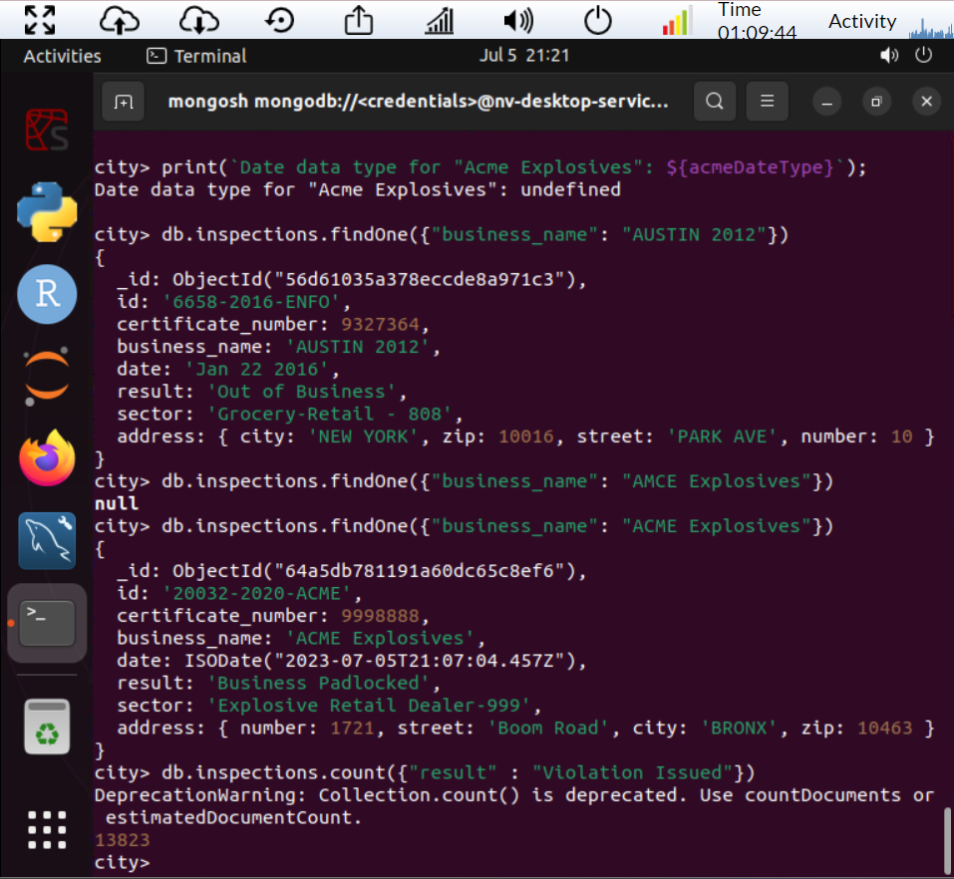

Verify by providing **screenshots** of the queries and results as evidence.

1. Using the appropriate command in the mongo shell, **update the document** with the ID “20032-2020-ACME” in the collection “inspections” in the database “city” with the information below.

|  |  |
| --- | --- |
| **Key** | **Value** |
| business_name | "New ACME Flowers" |
| Result | "Business Re-opened |
| comments | "Flowers after the explosion" |

Verify your database update using the appropriate **find()** function in the mongo shell. Provide a **screenshot** as evidence.

db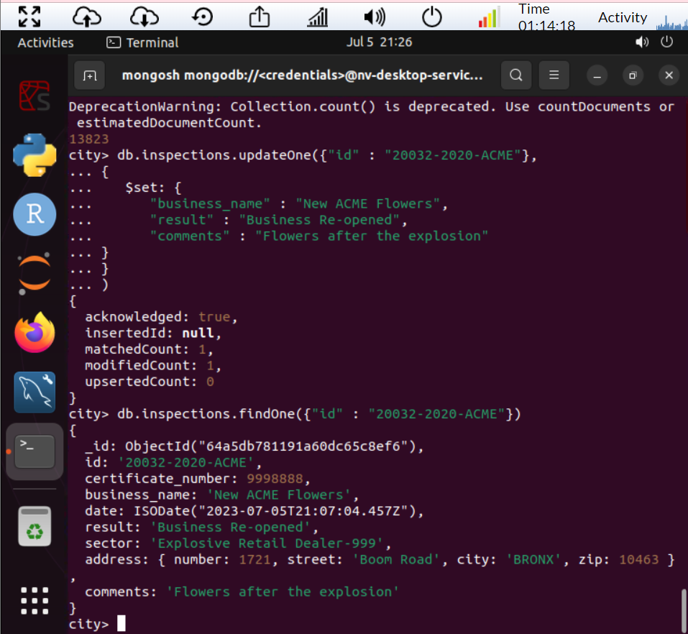

1. Using the database “city” with documents found in the “inspections” collection, perform the tasks listed below. Verify by providing **screenshots** of the results as evidence.
2. **Update all the documents** that contain the key-value pair "city":"ROSEDALE" in the address subdocument by changing the zip code in the address subdocument to "76114".

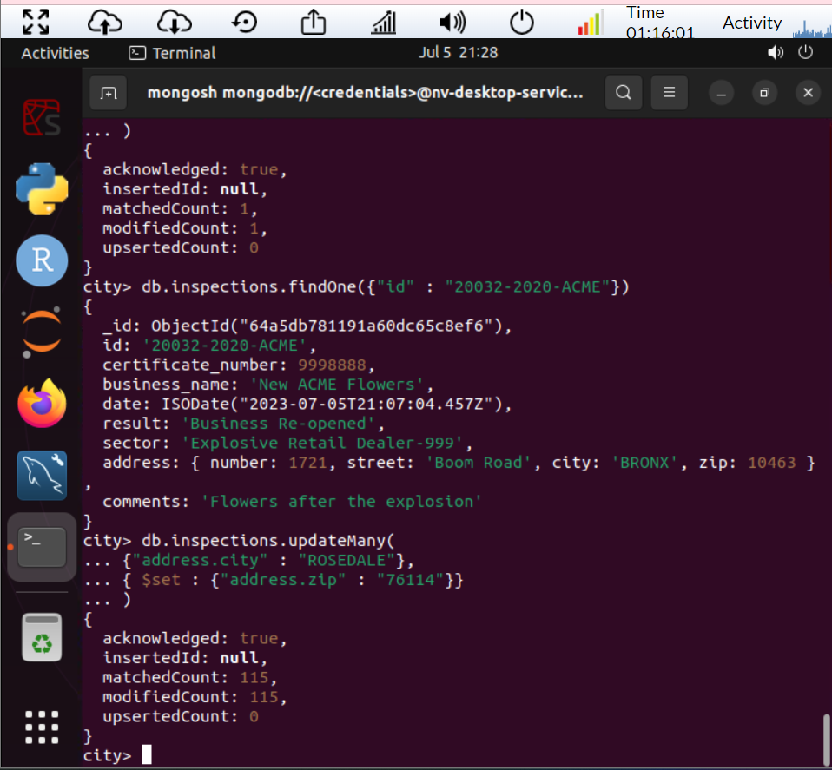

1. **Remove the first document** with the key-value pair "result":"Violation Issued."

